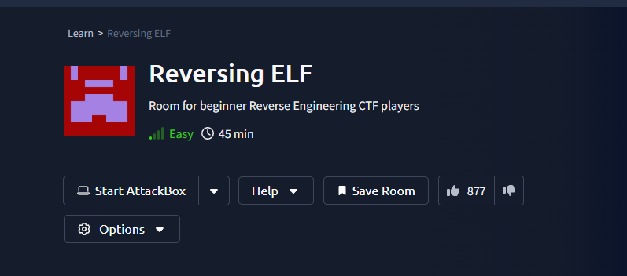

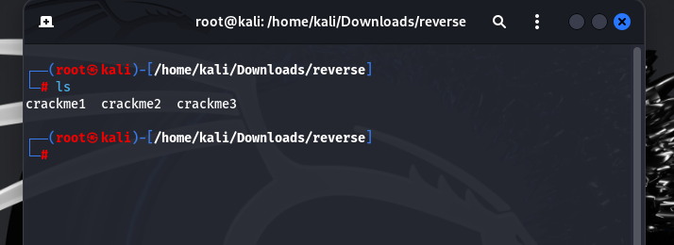

Crackme1

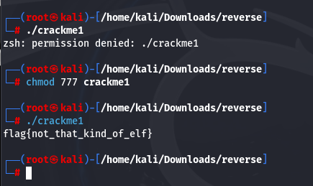

Crackme2

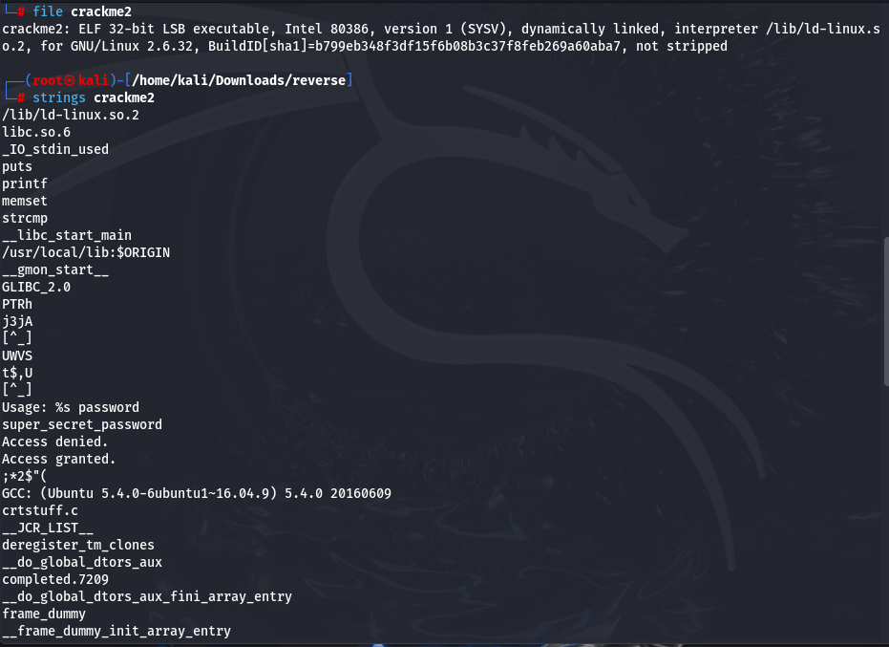

Strings crackme2

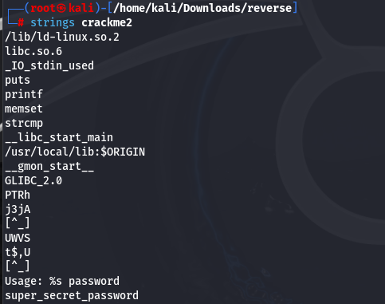

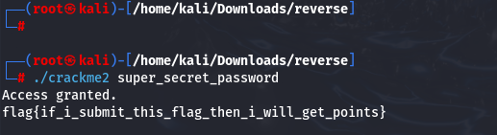

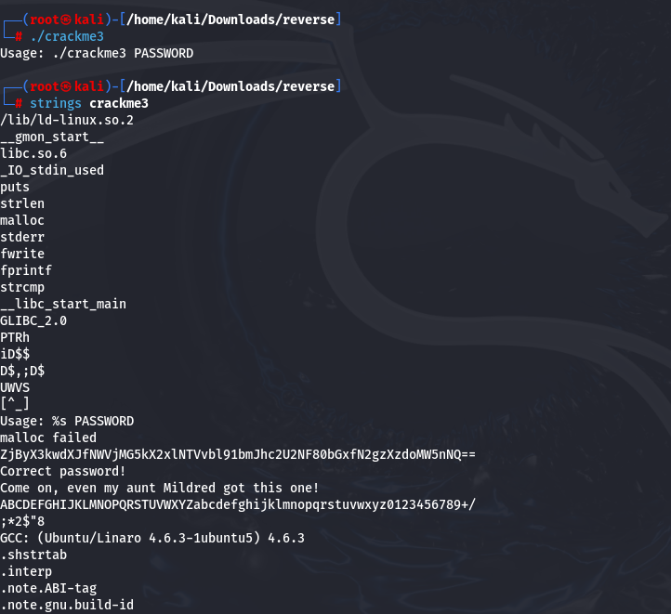

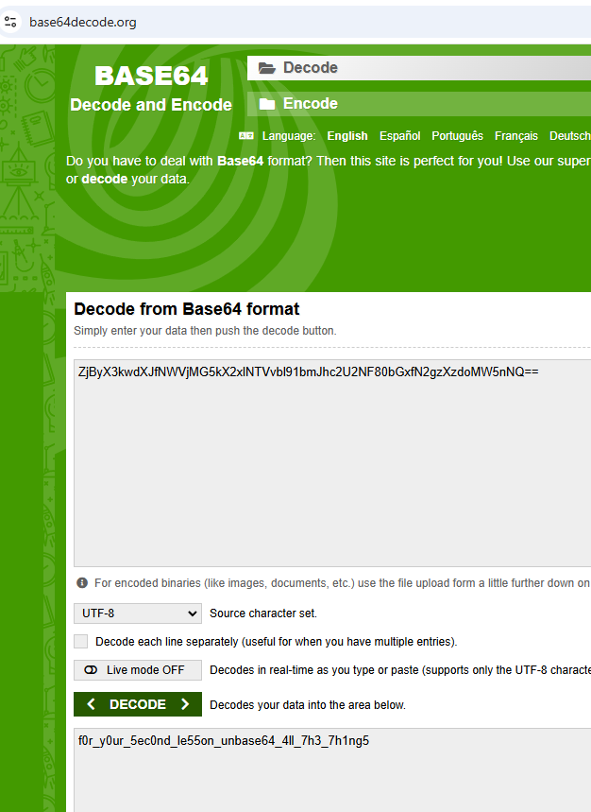

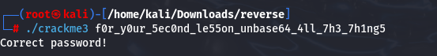

Crackme4:  Ikkilik uchun parolni tahlil qiling va toping?

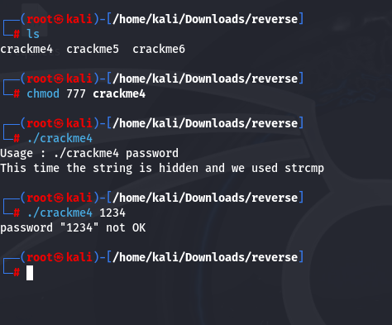

**Taxlil qilish uchun gdb dan foydalanamiz.**

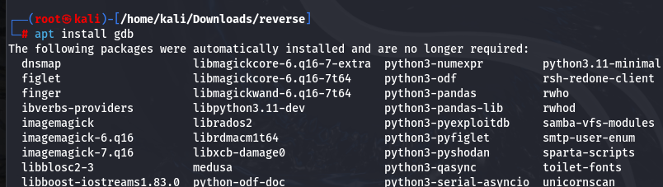

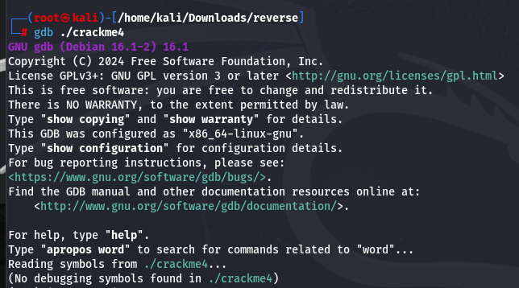

**Funksiyalarni ko’rish:**

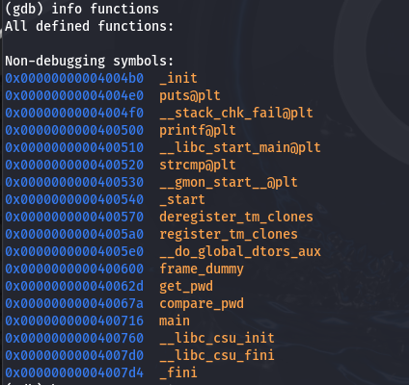



**strcmp()=>**U ikkita satrni taqqoslaydi va ular teng yoki teng emasligini qaytaradi.

Debug qilish:=> to'xtash nuqtasini tanlash.  **strcmp@plt** =>

 b *0x0000000000400520



**Endi test qilib koramiz**

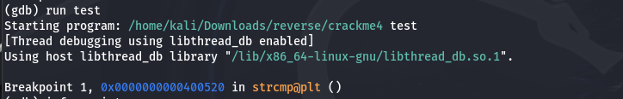

**Mavjud registrlar haqida malumot olish:**

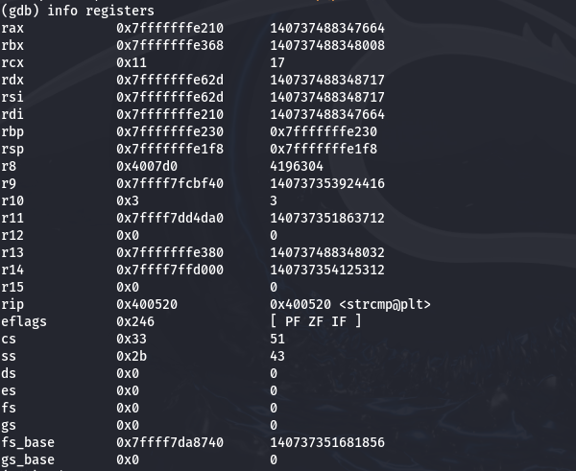

**Registrlar haqida malumot olish:**

**x/s register_address.**

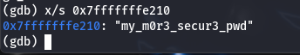

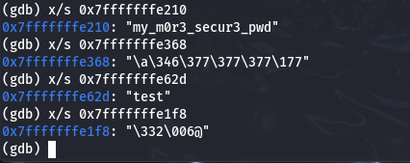

**ltrace**

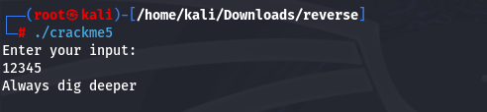

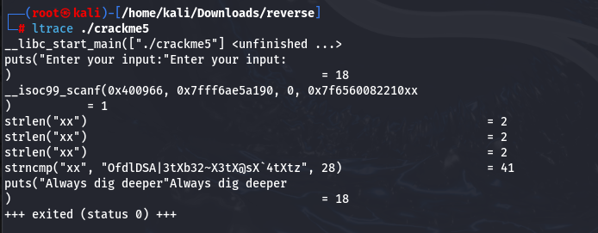

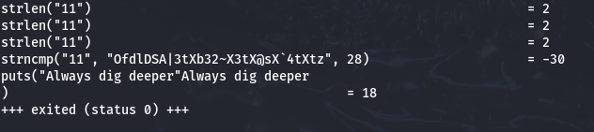

**Using online compliers**

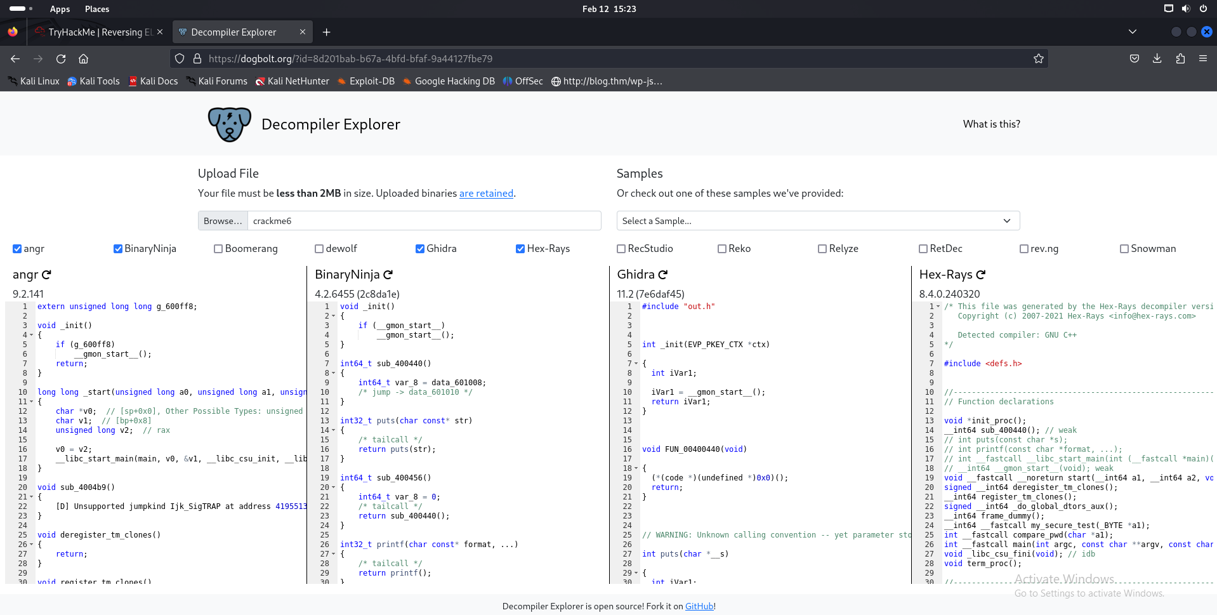

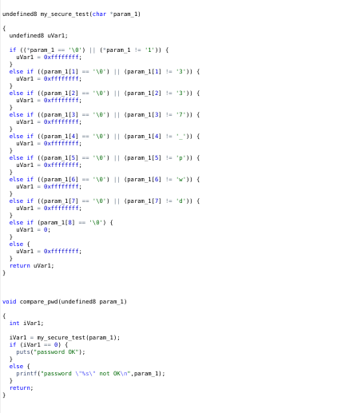

**Write it to the chatgpt:**

undefined8 my_secure_test(char *param_1) { undefined8 uVar1; if ((*param_1 == '\0') || (*param_1 != '1')) { uVar1 = 0xffffffff; } else if ((param_1[1] == '\0') || (param_1[1] != '3')) { uVar1 = 0xffffffff; } else if ((param_1[2] == '\0') || (param_1[2] != '3')) { uVar1 = 0xffffffff; } else if ((param_1[3] == '\0') || (param_1[3] != '7')) { uVar1 = 0xffffffff; } else if ((param_1[4] == '\0') || (param_1[4] != '_')) { uVar1 = 0xffffffff; } else if ((param_1[5] == '\0') || (param_1[5] != 'p')) { uVar1 = 0xffffffff; } else if ((param_1[6] == '\0') || (param_1[6] != 'w')) { uVar1 = 0xffffffff; } else if ((param_1[7] == '\0') || (param_1[7] != 'd')) { uVar1 = 0xffffffff; } else if (param_1[8] == '\0') { uVar1 = 0; } else { uVar1 = 0xffffffff; } return uVar1; } void compare_pwd(undefined8 param_1) { int iVar1; iVar1 = my_secure_test(param_1); if (iVar1 == 0) { puts("password OK"); } else { printf("password \"%s\" not OK\n",param_1); } return; }

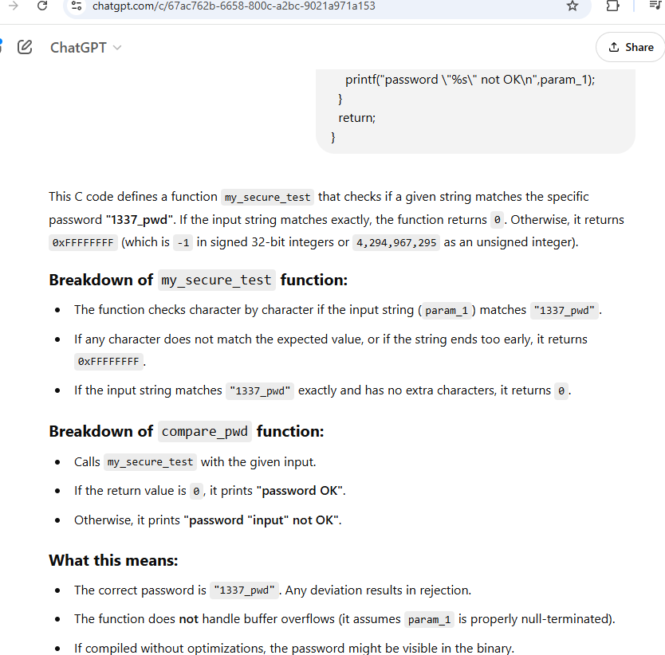

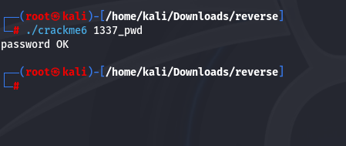

**Using online decomplier and chatgpt**

